Common metrics for success

Typically, when you set goals, you track your progress to see how close you are to reaching those goals. If you set a goal to finish a book every month for 12 months, you will probably check on your progress every now and then to see if you are accomplishing that goal. You may count pages with excitement as you go from book to book, or keep a checklist of book titles. The same practices can be applied to measuring marketing campaign effectiveness.

In this reading, you will learn the importance of measuring success. You will get an understanding of what you may want to track to measure success, and you will be reminded of what a metric is. Then, you will see where various metrics fit into your marketing funnel.

**Introduction to metrics**

As you go through this certificate program, you will learn a lot about metrics. For now, know that a **metric** is a quantifiable measurement that is used to track and assess a business objective. Metrics help determine the success of marketing initiatives and campaigns.

**Why track metrics?**

Tracking metrics helps digital marketers gauge how close they are to meeting goals. Each metric measures something specific, and therefore each metric tells a marketer something different about their campaign. Metrics can reveal important information about marketing campaigns, such as **return on investment (ROI)**, **return on ad spend (ROAS)**, **cost per sale**, and **online and sales revenue**.

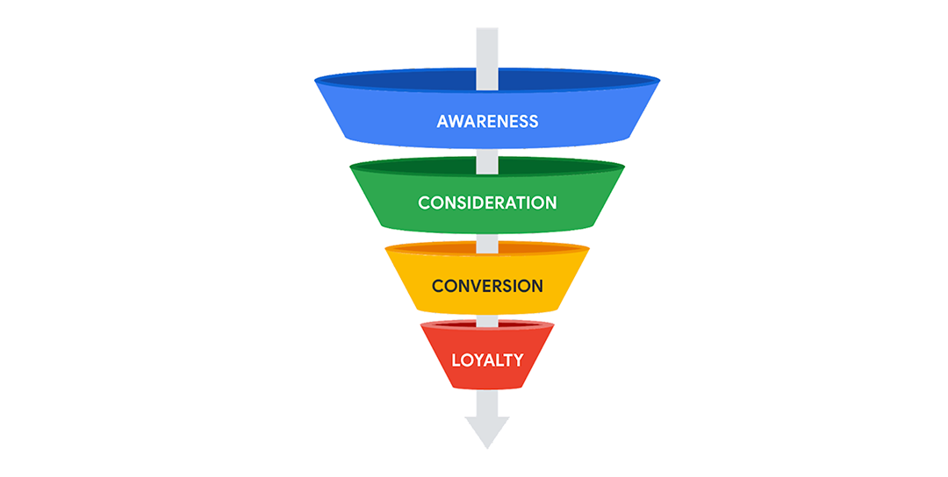

**Metrics in the marketing funnel**

You will apply different tactics to track metrics based on which stage of the marketing funnel you are operating in. For instance, in the **awareness** stage, you’ll gather audience data and develop user personas. This helps you get to know who your customers are. During the **consideration** stage, you will consider metrics like cost of acquisitions and click through rates. During the **conversion** stage, you will track and analyze sales conversion rates, average order values, and cart abandonment rates. And finally, during the **loyalty** phase, you’ll want to consider customer retention rate and customer lifetime value.

There are other factors to consider throughout the marketing funnel process, and these may not be familiar terms yet, but for now, this is a good place to start.

**Key takeaways**

Tracking metrics is critical to a campaign's success. Metrics help digital marketers gauge effectiveness and audience contentment while a campaign is happening. They also help marketers gain information and insights they can use for future campaigns.

Mark as completed

Like

Dislike

Report an issue

# Data ethics

In a previous video, you learned that performance marketing requires a lot of data. Data can contain information about user interests and behaviors and even individual customer purchases. This reading introduces you to data ethics. Knowing how to work with user data responsibly and legally is critical to the integrity of your organization, role, and projects.

## Data ethics

**Data ethics** is the study and evaluation of moral challenges related to data collection and analysis. When it comes to data, businesses apply ethical practices so they can:

* Follow regulations
* Demonstrate trustworthiness in protecting customer data
* Ensure the use of customer data is fair and without bias

### ****Follow regulations****

Many countries have laws regarding the generation, recording, curating, processing, sharing, and use of personally identifiable data. **Personally identifiable data (PID)** is information that can be used to directly identify, contact, or locate an individual. Make sure you are aware of your organization's data security and privacy protocols. **Data privacy** refers to the proper handling of data. How you collect, process, analyze, share, archive, and delete data should be in accordance with the data privacy laws of the countries where your customers reside.

### ****Protect customer data****

One important way to protect customer data is data anonymization. **Data anonymization** refers to one or more techniques to mask or remove personal information from data to protect the identities of people. Data anonymization is often performed on data coming from multiple sources. After the data has been anonymized, it can be more widely and freely shared in an organization. Types of data often anonymized are names, telephone numbers, email addresses, photographs, account numbers, and purchase transactions.

### ****Use data fairly and without bias****

Another ethical data practice is making sure that the data you collect and use is for legitimate business purposes. Fair and reasonable use of data also means that you don’t use the data in a biased manner. **Data bias** is a type of human error that skews results in a certain direction. Note that data bias isn’t the same as selecting data from a target audience. For example, let’s say you want to review historical data from customers between the ages of 21 and 45. That’s not data bias. What would be considered data bias is if you exclude the data from customers who returned products because you don’t consider them loyal to your brand. However, even when including all available data, you’re not always free of bias. This is possible if historical data was from an audience that wasn’t representative of all potential customers. If you create future ad campaigns based on previous customer behaviors, you could unknowingly perpetuate a bias.

**Pro tip:** To minimize the risk of data bias, ask for peer review of critical data that you intend to use so you can incorporate different perspectives right away.

## Key takeaway

Data ethics is important because it promotes the responsible use of customer data. Always be careful to follow the data privacy laws in your country and the countries where your customers live, protect customer data, and avoid data bias.

Mark as completed

Like

Dislike

Report an issue